
Company
Logotype

Cone Beam Computed Tomography- Report



Porur Dental X-rays & CBCT

Patient Name : Mr. Manavalan Muthukrishnan | Date of Report : 06.08.2024
Age/ Gender : 49 years/ Male | Region of Interest : CBCT Sectional Mandible
Referring doctor: Dr. Sujatha | Indication : Implant assessment
Clinical Notes: Nil
PATIENT INFORMATION

CBCT- Sectional Mandible provided
CBCT – IMAGE DETAILS

RADIOGRAPHIC INTERPRETATION

- Complete loss of crown and root structure in relation to 34.
- The alveolar bone in relation to 34 is present with normal trabecular pattern.
IMPLANT ASSESSMENT

 | 34 region
Sub-Crestal (in mm) | 6.27
Mid- Crestal (in mm) | 8.44
Distance between alveolar ridge and the inferior border of mandible (in mm) | 23.47
Distance between distal portion of 45 and mesial portion of 47  (in mm) | 5.85

RADIOGRAPHIC IMPRESSION

- Partially edentulous region: 34.

Kindly correlate with clinical findings


IMAGES FOR REFERENCE

RECONSTRUCTED PANORAMIC VIEW
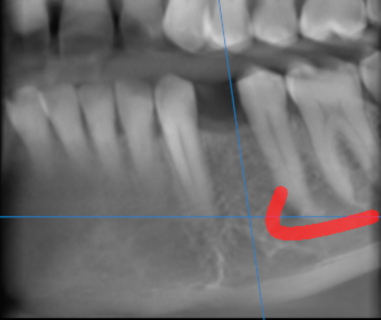

3-DIMENSIONAL VIEW

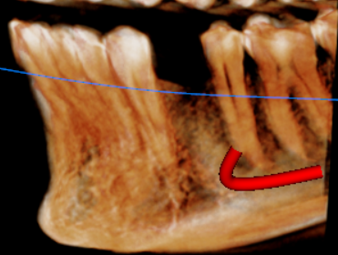

CROSS SECTIONAL VIEW

34 region | 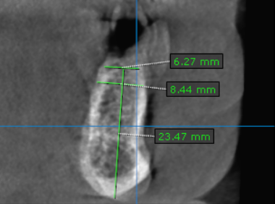

**** End of report ****

